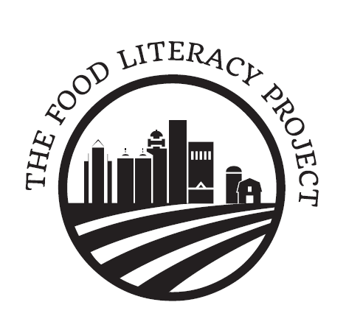

Privacy Policy
Your privacy is important to us. To better protect your privacy we provide this notice explaining our online information practices. We use cookies, which are small digital files that help us track your visits to this site in order to provide the best user experience possible. Most web browsers allow you to opt out of cookies if you so desire; visit your web browser’s security settings to see how to opt out. The Food Literacy Project will never sell, rent, share or exchange your data to third parties. Any information collected during the donation process will only be used to process the donation. To prevent unauthorized access, maintain accuracy, and ensure the correct use of information, we have put in place appropriate physical, electronic, and managerial procedures to safeguard and secure any information that we collect. If you have questions about our privacy practices, you can contact us at the postal or email address posted on this site. If you have any questions, please contact the Food Literacy Project at 502-795-3365 or info@foodliteracyproject.org

