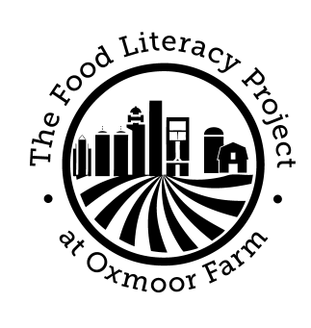
Youth Community Agriculture Program

Position: Crew Member

Job Importance:
The Food Literacy Project at Oxmoor Farm’s mission is inspiring a new generation of people to build healthy relationships with food, farming and the land. We envision a just and sustainable food system in which people foster a deep understanding of what connects us to each other and the natural world. YCAP seeks to cultivate a new generation of leaders by engaging youth in growing, cooking and marketing fresh foods, exploring the food system and building food justice in their own community. Using food as a vehicle for personal growth and social change, we inspire young people to take an active role in their food system and create a healthier community.
Responsibilities:
Over the course of 7 weeks between June 16th and August 1st 2015, crew members are expected to:
- Work 4-5 days per week (approximately 30 hours).
- Plant, cultivate and harvest vegetables using organic methods on Oxmoor Farm.
- Advertise and sell produce at a variety of local vendors including Farmers markets.
- Investigate food justice issues that affect the Louisville community.
- Develop recipes using seasonal farm produce & create and serve a from-scratch community meal.
- Demonstrate a strong sense of responsibility, dependability and punctuality.
- Adhere to the Food Literacy Project’s Health and Safety Guidelines and Behavioral Standards.
- Maintain a strong work ethic throughout the entire 7 weeks.

Qualifications:
- 16 – 19 years of age on June 1, 2015.
- Must have completed the Mayor’s Summer Works registration process
  - www.KentuckianaWorks.org and click on the “Mayor’s SummerWorks” link
- Ability to perform rigorous and demanding outdoor physical farm labor including: digging, bending, lifting (less than 50 lbs.), squatting and kneeling in Kentucky summer conditions.
- Prepared to work outside in all types of weather.
- Interest in food systems, building the local food economy, food access, cooking, sustainable agriculture, the environment & community service.
- Openness to personal growth & desire to build job and leadership skills.
- Ability to work and communicate in a team as well as independently.

Questions: Contact Kitty Nowak, Program Manager kitty@foodliteracyproject.org or 491-0072
www.foodliteracyproject.org

